Sarah Martin

C00257967

Lab 7

# Knative Functions

## Installing Knative Functions

I used homebrew to install “func”

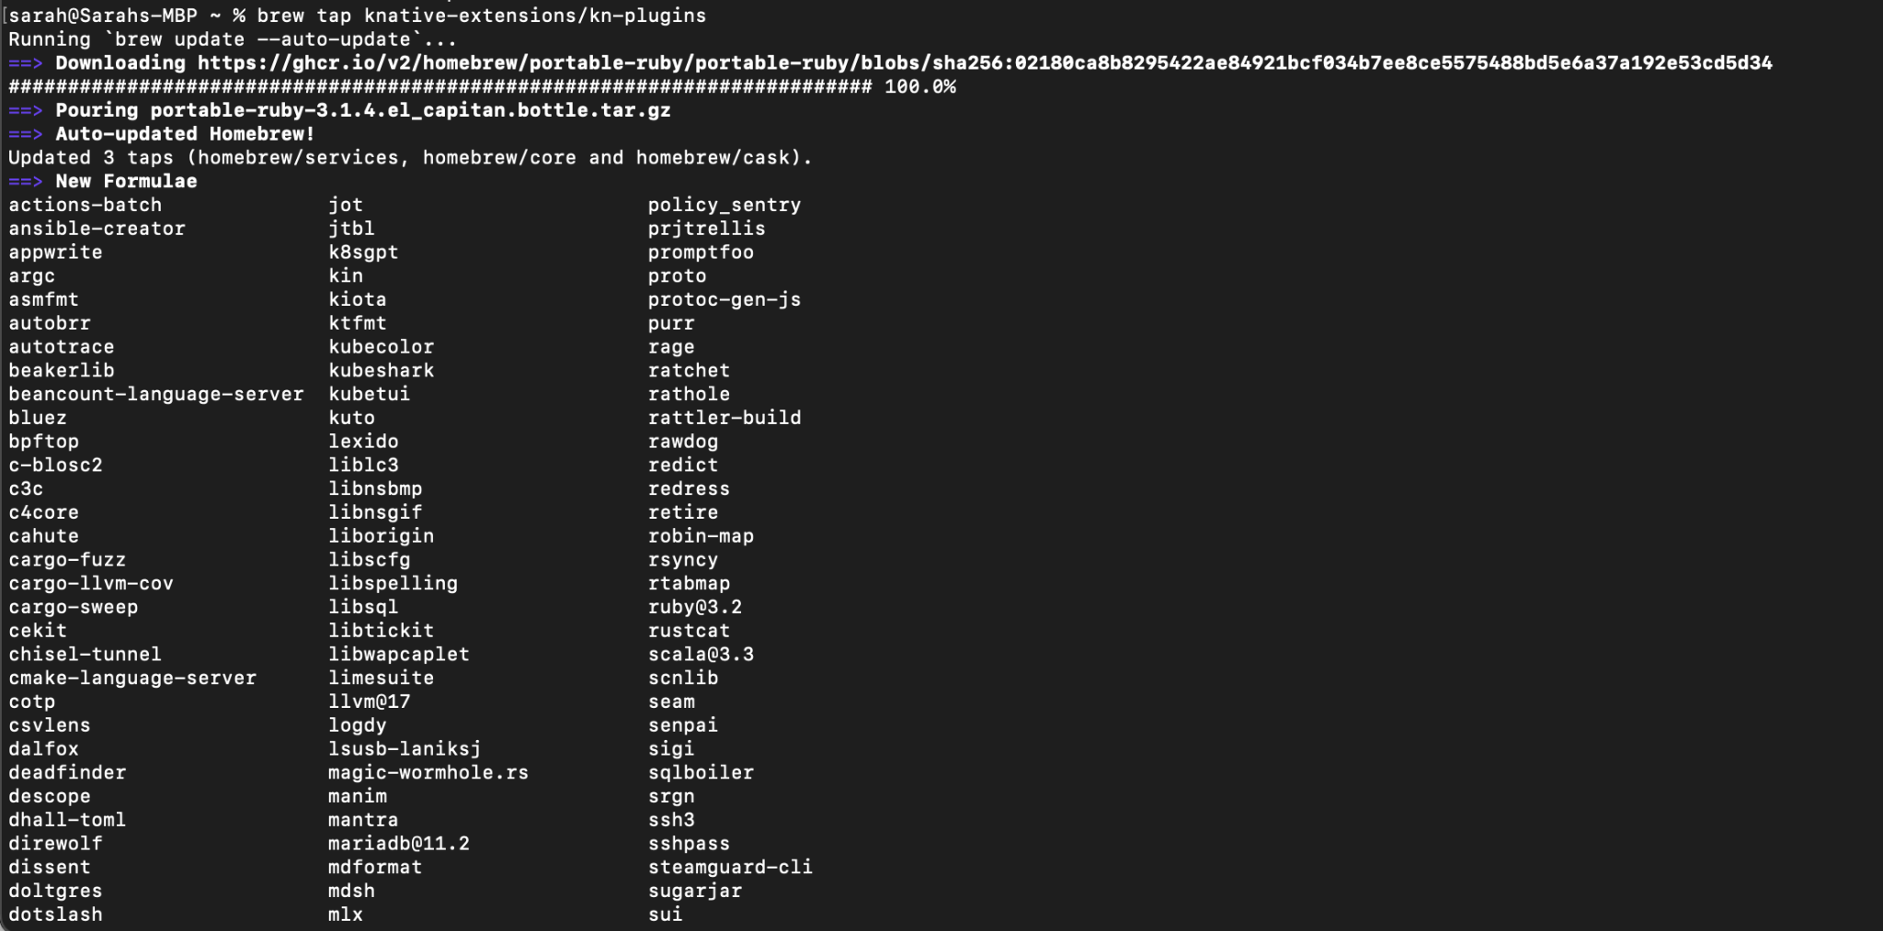

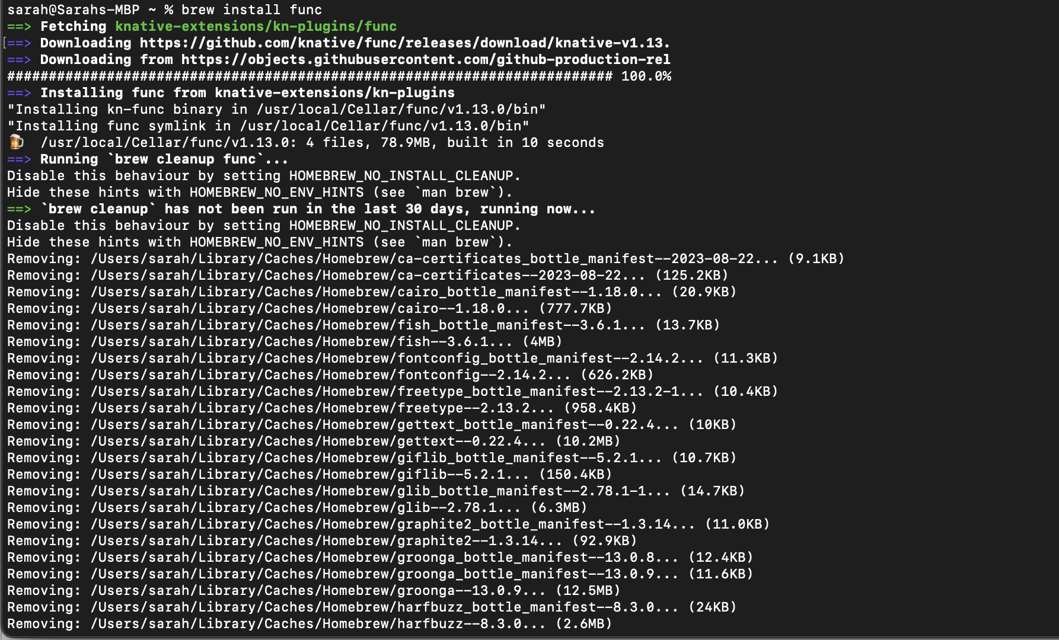

I used homebrew to then install the Kn function and checked its version.

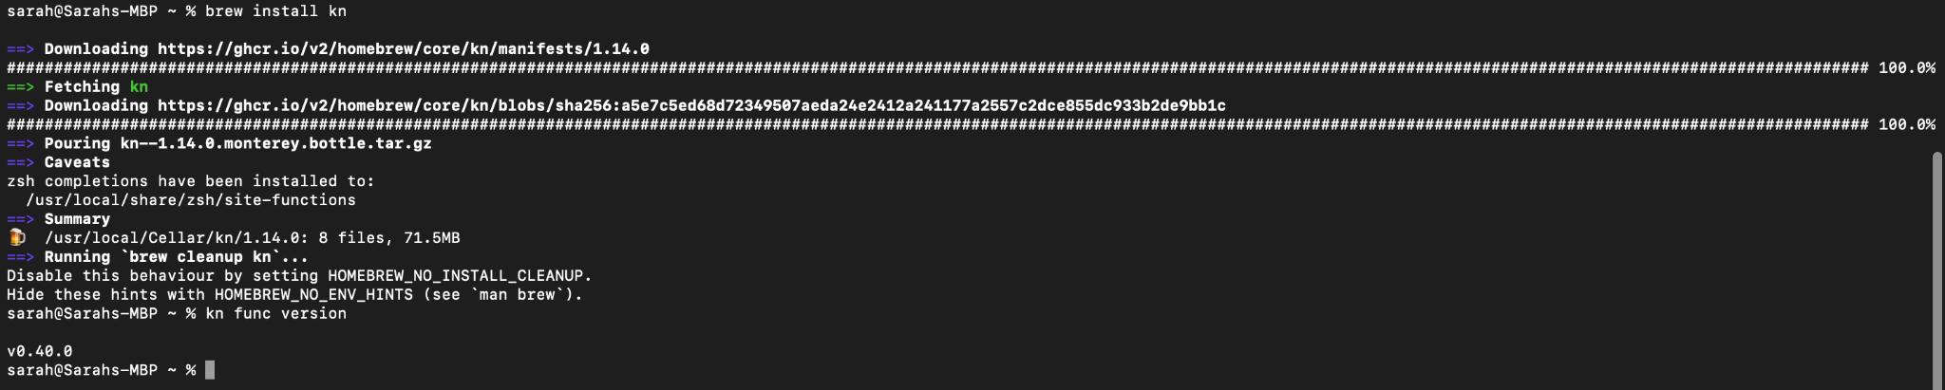

## Creating A Function

I created a function project by using the **func** CLI

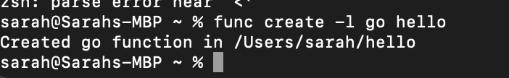

I then CD into hello.

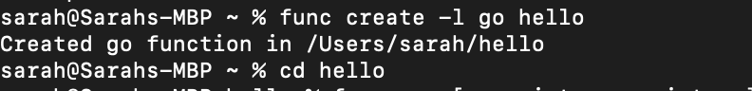

## 

## 

## 

## 

## 

## 

## Building, running, or deploying functions

I ran the function locally by running the “kn func run” command inside the project directory.

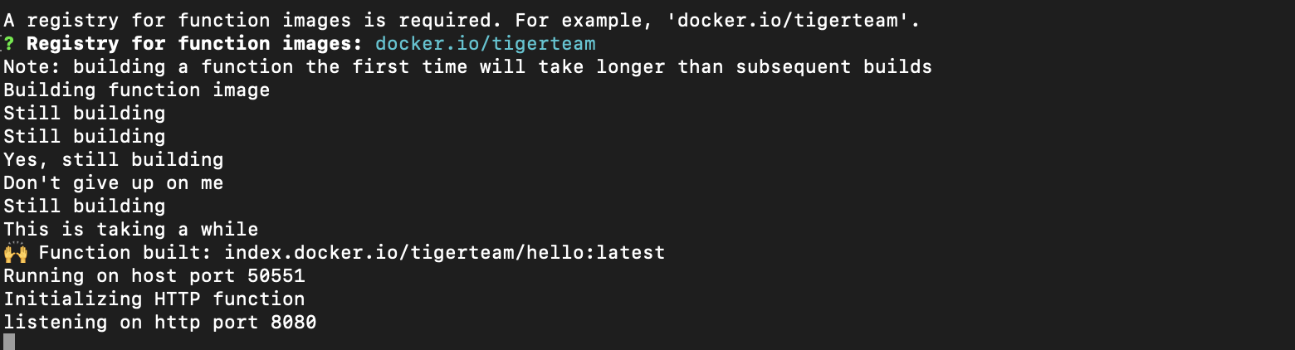

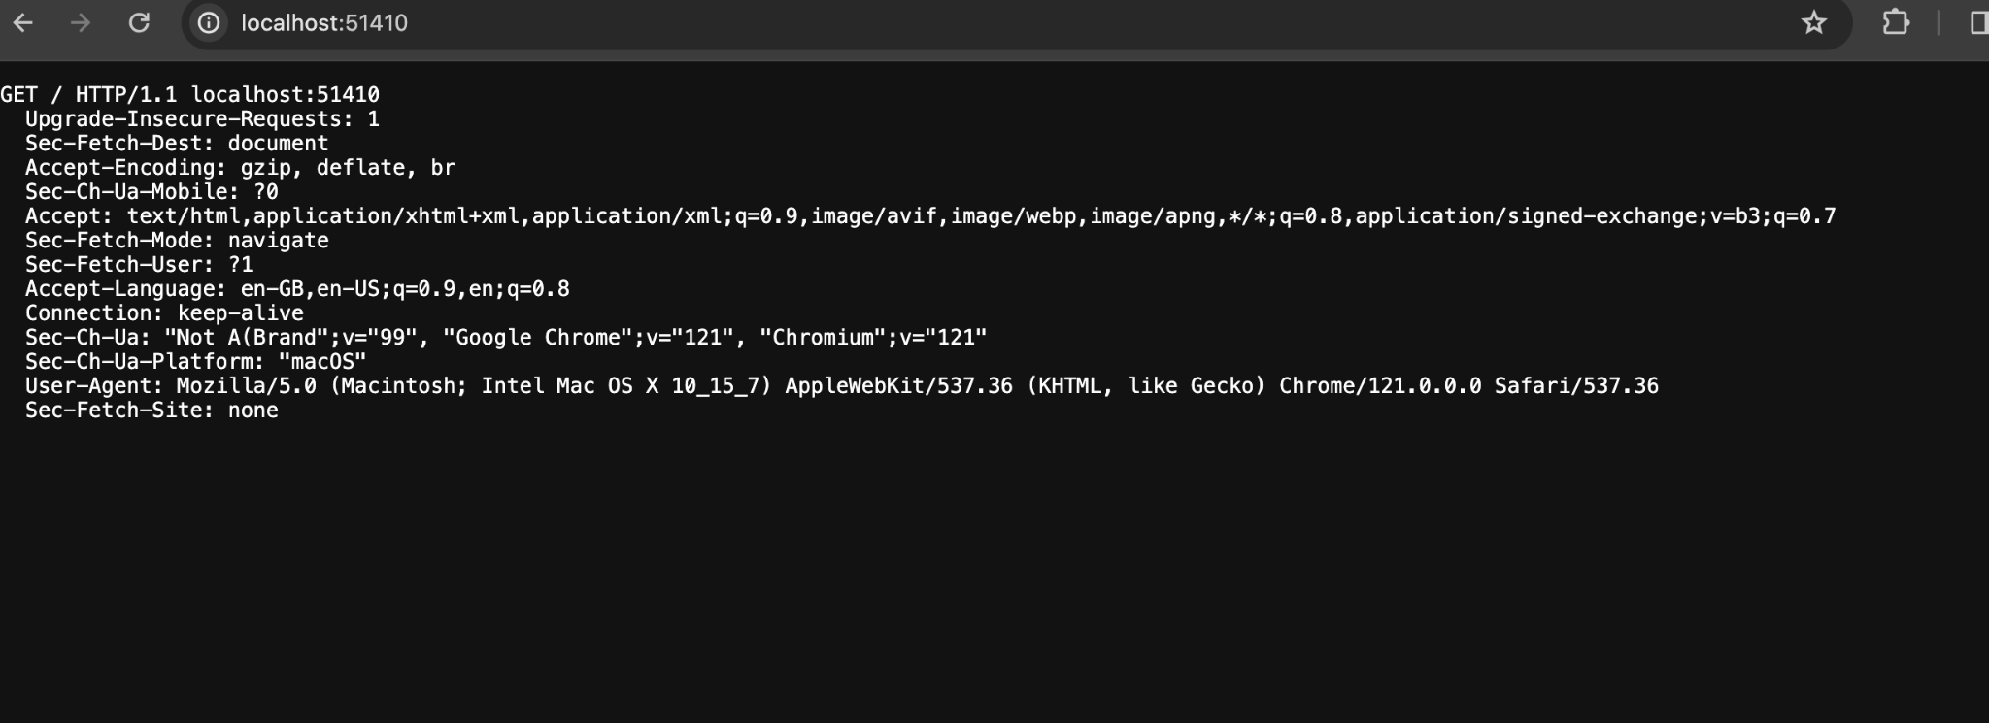

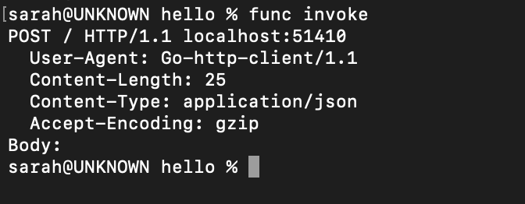

For the next part i couldnt complete as I kept getting errors and the terminal kept freezing when I tried the autoscaling part repeatedly.

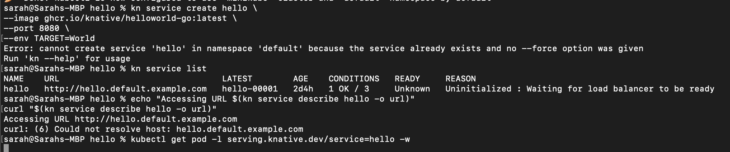

Due to not being able to solve these errors, I was not able to complete the rest of this lab.